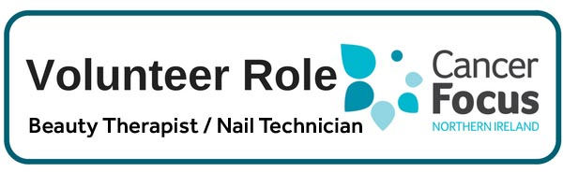

**Purpose of Role**

**This role helps support the work of Cancer Focus NI’s Nail Bar** by providing nail treatments and hand massages to patients waiting for their treatment in the Bridgewater Suite of the City Hospital, Belfast and Outpatients at Craigavon Area Hospital.

Volunteers will be providing much needed relaxation and pampering to people at a very stressful time, in addition to advice on caring for their nails and skin which can be adversely affected by chemotherapy

**What Can I Expect from the Role?**

* This is an ideal role for someone who has qualifications in Beauty Therapy and is looking for some additional experience and to support local people affected by cancer.
* Meet other like-minded people and join our ever growing team of Volunteers.
* Develop skills and gain valuable experience which you can include on your CV.
* Help make a difference to local cancer patients and their families.

**Location**

This service is provided in the Belfast City Hospital and Craigavon Area Hospital. Occasionally you may be asked to provide treatments at the CFNI Building on Eglantine Ave, Belfast; at CFNI Support Groups or at fundraising events.

**What Skill or Experience do I need?**

* **NVQ Level 2 or 3 in Beauty Therapy** is needed to be able to give the standard of treatment required. Experience would be beneficial but not essential.
* As clients will be dealing with a cancer diagnosis you will also need to be empathetic, enjoy connecting with others and be happy to take instruction.

**Hours**

Generally one or two weekdays per month – morning or afternoon. Hours are flexible and will be decided in discussion with our Beauty Therapist dependant on your availability.

**Training & Support**

**Full training and support will be provided** by Cancer Focus NI, and you will work under the guidance and supervision of the Cancer Focus NI Beauty Therapist.

Out of pocket expenses will be reimbursed in line with agreed guidelines.

**Other Details**

The recruitment process includes an application form, a meeting with our Beauty Therapist, references and Access NI criminal checks.