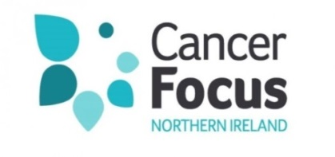

Cookie Policy

What Are Cookies?

Cookies are small text files placed on your computer by websites you visit.

They are widely used to make websites work more efficiently for visitors and to provide information to the owners of the site. Some of the cookies we use are essential in order for parts of the website to operate.

How Do We Use Cookies On The Website?

We use cookies on the website for our own internal purposes to track how users navigate through the website. This helps us to evaluate and improve the Cancer Focus NI website and our online services. When someone visits our website we collect standard internet log information and details of visitor behaviour patterns. We do this to find out things, such as the number of visitors to the various parts of the site. We collect this information in a way which does not identify anyone. We do not make any attempt to find out the identities of those visiting any part of our website. We will not associate any data gathered from this site with any personally identifying information from any source.

Managing Cookies

In your web browser you can control which types of cookies you allow. You can turn cookies on or off using your browser's settings. You can also delete cookies and clear your browser's cache (history). The Help function within your browser should tell you how. Alternatively, you may wish to visit www.aboutcookies.org which contains comprehensive information on how to do this on a wide variety of browsers. For information on how to do this on the browser of your mobile phone, you will need to refer to your handset manual. Please be aware that restricting cookies may impact on the functionality of the website.

Third Party Cookies

We use Google Analytics to supply site analytics for our website usage to improve the way we present our website www.google.com/intl/en/privacypolicy.html.

When you visit a page with content embedded from, for example, Facebook, YouTube or Twitter, you may be presented with cookies from these websites. Cancer Focus NI does not control the dissemination of these cookies. You should check the relevant third party website for more information about these as they will govern the use of information you submit or which is collected by cookies whilst visiting these websites.

- Facebook: www.facebook.com/about/privacy
- Twitter: http://twitter.com/privacy
- YouTube: http://www.google.co.uk/intl/en/policies/privacy
To find out more about cookies, including how to see what cookies have been set and how to manage and delete them, visit www.allaboutcookies.org.

To opt out of being tracked by Google Analytics across all websites, visit http://tools.google.com/dlpage/gaoptout.

