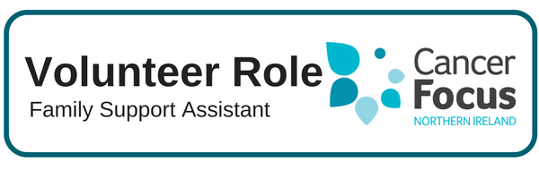

**Other Details**

The recruitment process includes an application form, a meeting with our Volunteer Co-Ordinator and/or Family Support Worker, references and Access NI criminal checks.

**Purpose of Role**

**Our Family Support Service provides help to families where there is a significant adult with a cancer diagnosis**. An essential part of that help is to support the children through a difficult and scary time in their lives through talking and creative play. This voluntary role assists the Family Support Worker with the smooth running of our children’s groups, Bereavement projects and Parents Support Evenings.

**What Does it Involve?**

* **To help set up the rooms and prepare the activities for the children**.
* **To take part in the group on all levels to support the children - holding discussions/role play etc**.
* **To provide a supportive and welcoming environment for children and adults, listening to their concerns and responding appropriately**.
* **To help with arts and crafts**.
* **To play with the children**.
* **To clear up after activities and refreshments**.

**What Can I Expect from the Role?**

* Meet other like-minded people and join our ever growing team of Volunteers.
* Develop skills and gain valuable experience which you can include on your CV.
* Help make a difference to local cancer patients and their families.

**Location**

**Cancer Focus Northern Ireland, 40-44 Eglantine Avenue, Belfast BT9 6DX**

**What Skill or Experience do I need?**

**You should be 21 or over and will need:**

* **Experience of working with children**.
* **An ability to use your initiative**.
* **An ability to be calm and dependable and adapt to changing situations**.
* **To be able to play and have fun**.
* **Excellent interpersonal skills and be able to work as part of a team.**

**Hours**

**Evenings**

**Training & Support**

**Initial training and ongoing support will be provided by Cancer Focus NI**, together with any necessary training required to help you fulfill this role. ‘Out of pocket’ expenses will be reimbursed in line with agreed guidelines.