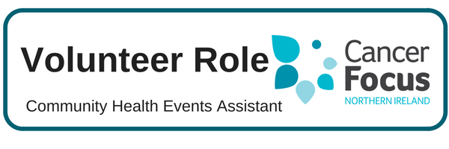

**Purpose of Role**

**This role involves engaging with individuals, in an informal manner, at venues around N Ireland to raise awareness of the charity, our services, cancer prevention messages and healthy lifestyle choices.**

**What Does it Involve?**

* **You will work as part of a team representing the charity at health events and information stands in various areas providing advice and information with the ultimate aim of informing the public about our services and reducing the incidence of cancer.**

**What Can I Expect from the Role?**

* Support from dedicated staff who will provide advice and practical support.
* Develop skills and gain valuable experience which you can include on your CV.
* Flexibility to fit your volunteering role in to your own commitments and lifestyle.
* Satisfaction in knowing you are making a difference to local cancer patients and their families

**Location**

**Various venues throughout Northern Ireland as required**.

**What Skill or Experience do I need?**

* **Ability to relate well to other people / good interpersonal skills**.
* **Reliable and responsible disposition**.
* **Access to a car**.

**Hours**

**Mostly weekdays – ideally one day per month minimum for 6 months+**

**Training & Support**

**One day’s practical training with a member of staff covering knowledge of how to use demonstration models and associated information**. Initial supervision and guidance at health fairs is followed by full support provided by Cancer Focus NI. ‘Out of pocket’ expenses will be reimbursed in line with agreed guidelines.

**Other Details**

The recruitment process includes an application form, a meeting with our Volunteer Co-Ordinator and references. We also offer 16-25 year olds the opportunity to take part in the Millennium Volunteers certificated scheme which is endorsed by DSD and Volunteer Now.

Health Promotion Volunteer