CANCER FOCUS NORTHERN IRELAND

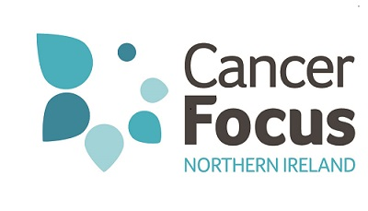

JOB DESCRIPTION

Job Title: Internship - Schools Programme Delivery
(Suit students seeking classroom experience for PGCE applications
or working with young people)

Responsible To: Programme Coordinator, Schools and Young People

Location: 40-44 Eglantine Ave, Belfast, BT9 6DX (working in schools in home area)

Duration: 46 weeks

Bursary: £5,000 pa plus travel costs

Start: 2nd September 2019 (or as soon as possible after this date)

Applications: CV and cover letter to eileendonnelly@cancerfocusni.org

Application Deadline: 5pm Monday 26th August 2019

Main responsibilities: To facilitate the delivery of Cancer Focus NI cancer prevention programmes in schools and Regional Colleges. Successful applicants will work as part of a wider team with a comprehensive induction programme and support available throughout the placement.
Generic duties
Deliver cancer prevention programmes in Primary/Post Primary Schools and Regional Colleges in NI
- Manage own portfolio of schools, building rapport and establishing relationship with teachers
- Communicate regularly with established contacts through visits, telephone, email and postal enquiries as relevant
- Attend meetings reporting on targets and assisting with monitoring and evaluation
- Prioritise workload to cater for schools in areas of social deprivation
- Attend community events within Interns geographical area as required
- Attend training sessions as appropriate
- Adhere to Cancer Focus NI policies and procedures including social media, safe guarding, receiving donations, health & safety. etc.
- Liaise with other Cancer Focus NI departments as required
- Conduct a research project of your own interest and the organisation
- Any other duties as determined by Line Management

Successful candidates must hold a full, current driving licence and have access to the use of a car or other appropriate form of transport to carry out the duties of the post.
Previous experience of working with young people would be an advantage

