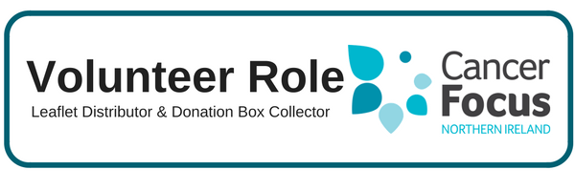

**Other Details**

The recruitment process includes an application form, a meeting with our Volunteer Co-Ordinator and references.

**Purpose of the Role**

To support Cancer Focus Northern Ireland’ in your local community by joining a team of enthusiastic and motivated individuals promoting our work and services and increasing our capacity to support people affected by cancer.

**What does it involve?**

* Leaflet Distribution – identify suitable locations, obtain permission and deliver supplies of various leaflets and posters to help promote the work and activities of the charity.
* Collection Boxes - maintain current outlets and identify potential new collection box sites, pick up boxes when full (normally on a 3 month cycle) and leave new boxes in their place.
* Keep records of where leaflets and collection boxes are located and relay this to the volunteer team when required.
* Occasional fundraising activities; always as part of the larger volunteering team.

**What can I expect from the role?**

* Support from dedicated staff who will provide advice and practical support.
* Gain knowledge of the work of Cancer Focus NI at the same time as meeting new people and developing your communication skills.
* Flexibility to fit your volunteering role in to your own commitments and lifestyle.
* Satisfaction in knowing you are making a difference to local cancer patients and their families

**Location**

We want to develop a team of volunteers to spread the word and this role will be based primarily in your local area.

**What skill or experience do I need?**

* Experience – none required as full support and training will be provided to help you fulfil this role.
* Personal qualities – sociable, enthusiastic, self-motivated, reliable and good organisational skills.
* Access to a car when collecting and delivering boxes.

**Hours**

At least 8 hours per month of your spare time will make a BIG difference – flexible to fit in with your lifestyle. We are looking for volunteers who will be available over the long term to build up contacts and relationships within their own community.

**Training & Support**

**Full support will be provided by Cancer Focus NI**, together with any necessary training required to help you fulfill this role.

‘Out of pocket’ expenses will be reimbursed in line with agreed guidelines