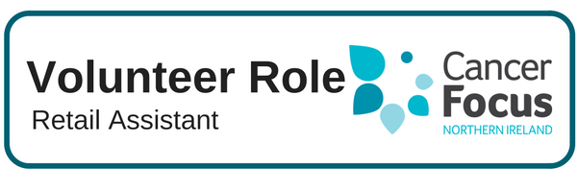

**Other Details**

We also offer 16-25 year olds the opportunity to take part in the Millennium Volunteers certificated scheme which is endorsed by DSD and Volunteer Now. For more information call into your local Cancer Focus NI shop.

**Purpose of Role**

All our Volunteers play a vital role in helping to raise the profile of Cancer Focus NI and increase knowledge and awareness of the charity, our aims, work and services within your local community.

**Our shops in particular provide an essential part of the income necessary to maintain our Care Services & Cancer Prevention Programmes.**

**What Does it Involve?**

Volunteers work as part of a team undertaking one of two roles within the shop:

**Front of Shop**

* Merchandising and display of clothes and other goods
* Operating the till
* Providing excellent customer service
* General housekeeping to maintain a high standard of appearance

**Store Area**

* Receiving and sorting donations
* Preparing items for sale
* General housekeeping to ensure a safe environment & accessible goods

**What Can I Expect from the Role?**

* Meet other like-minded people and join our ever growing team of Volunteers.
* Develop skills and gain valuable experience which you can include on your CV.
* Flexibility allows you to fit volunteering into your lifestyle and current commitments.
* Help make a difference to local cancer patients and their families.
* Flexibility to fit your volunteering role in to your own commitments and lifestyle.
* Satisfaction in knowing you are making a difference to local cancer patients and their families.

**Location**

Cancer Focus NI Charity Shop (locations across Northern Ireland)

**What Skill or Experience do I need?**

* Previous retail experience is an advantage and it is important that you get on well with others, enjoy meeting people and can work well as part of a team.
* If you have an eye for fashion, experience with creative crafts and display or knowledge of antiques and collectables this could be the ideal role for you.

**Location**

Cancer Focus NI Charity Shop (locations across Northern Ireland)

**Hours**

Shops are open Monday to Saturday and volunteers undertake morning or afternoon shifts.