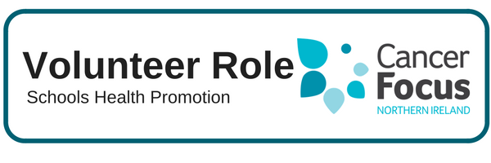

**Other Details**

The recruitment process includes an application form, an informal meeting, references and Access NI checks.

**Purpose of Role**

To ensure local young people are provided with the correct information to make positive lifestyle choices. To maintain the reputation of Cancer Focus NI as a provider of top quality programmes in local schools.

**What Does it Involve?**

* Liaising with Cancer Focus NI and school staff to organise school visits.
* Delivery of structured, interactive power point presentations to whole year groups of students. Each programme lasting approx. 45 minutes.

**What Can I Expect from the Role?**

* Satisfaction in knowing you are empowering young people to make informed decisions about their future health with high quality programmes.
* Support from dedicated staff who will provide training, advice and practical support.
* Flexibility to fit your volunteering role in to your own commitments and lifestyle.

**Location**

We want to develop a team of volunteers who can visit schools across the province and deliver our interactive health promotion programmes to students.

**What Skill or Experience do I need?**

* Relevant experience is essential, particularly in addressing large groups of young people.
* Personal qualities –sociable, organised and reliable.
* Access to a car is preferable but not essential.

**Hours**

One to three weekdays per month – flexible around your commitments.

We are looking for volunteers who will be available over the long term as we expand our presence in primary and post primary schools.

**Training & Support**

Training will include an initial induction followed by “on the job” training with a member of staff. Out of pocket expenses / travel expenses will be reimbursed in line with agreed guidelines.