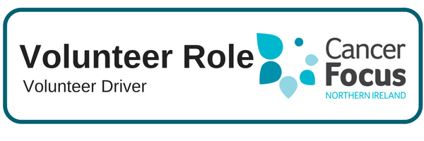

**Purpose of Role**

Many patients find travelling to hospital for multiple appointments very time consuming, expensive and stressful if they have to rely on public transport. **As a volunteer driver you will be providing essential transport for cancer patients to and from their cancer specific appointments**.

**What Does it Involve?**

* Providing cancer patients with door to door transport from their home to the hospital in time for their appointments, and taking them home again afterwards. The days and times will vary according to the needs of the patients.
* Volunteers will be providing the service as part of a team and according to a co-ordinated rota and need to be punctual, reliable, able to co-operate with others and to fulfil their commitments according to our guidelines and training.

**What Can I Expect from the Role?**

* Meet other like-minded people and join our ever growing team of Volunteers.
* Develop skills and gain valuable experience which you can include on your CV.
* Flexibility allows you to fit volunteering into your lifestyle and current commitments.
* Help make a difference to local cancer patients and their families.

**Location**

Transporting patients from their home address to hospital appointments (usually to the Ulster Hospital or Belfast City Hospital complexes)

**What Skill or Experience do I need?**

* This role is suitable for someone who enjoys meeting people and has good communication and organisational skills.
* It is essential that volunteers are 21 or over and have a full driving licence and access to a comfortable and roadworthy vehicle with the relevant documentation – insurance certificate, MOT certificate.

**Hours**

**Flexible – weekdays**

**One day per month minimum with a commitment of 6 months+**

**Training & Support**

There will be a comprehensive two-day training session provided covering all aspects of the role. In addition any further training required to help you fulfill this role will be provided by Cancer Focus NI. Fuel expenses will be reimbursed as will any additional vehicle insurance costs incurred as a result of taking part in the service. Any other out of pocket expenses will be reimbursed in line with agreed guidelines.

**Other Details**

This service currently operates in the South Eastern and Belfast Health Trust areas. This role entails an application process including an Access NI police check, reference check and training.