Director of Corporate Affairs
Recruitment Information Pack

Contents

Introduction 3

Our Story to Date 4

Our Vision, Our Mission 4

Our Values 6

Our Services 6

Finances 7

Meet the Trustee Board 8

Organisational Structure 9

Job Description 10

Person Specification 12

Application Process 15

Guidance notes on completing your Application Form 15

Introduction

Dear Applicant

Thank you for your interest in the role of Director of Corporate Affairs of Cancer Focus Northern Ireland. We are seeking an individual who is passionate about our work. This Information Pack includes information about Cancer Focus NI, sets out the process for recruitment and outlines the qualifications, skills and experience we are seeking.

Cancer Focus NI is a local voluntary organisation that aims to eliminate cancer, where possible, and reduce its impact on our society. We were Northern Ireland’s first cancer charity and in 2019 we celebrated our 50th Anniversary. Since our founding we have had four main pillars of endeavour: cancer prevention, services to people affected by cancer, funding local cancer research and campaigning and advocacy work. While we have stayed true to our founding principles, how we have delivered on our mission has grown and developed over the years.

Cancer Focus NI is looking for an exceptional individual who will provide strategic and visionary leadership to manage the corporate affairs within the organisation. The postholder’s portfolio will include the management of finance, IT, personnel, facilities and general management duties. As an integral member of the Senior Management Team, the postholder will contribute to the overall strategic management and direction of Cancer Focus NI.

We invite you to read through this Information Pack and understand more about the role and the person we are looking for, then decide whether you feel you have the necessary skills, experience and qualities to be the Director of Corporate Affairs.

If you have any enquiries about this post, please do not hesitate to contact Julie McConville by emailing juliemcconville@cancerfocusni.org or telephone 028 9068 0744.

The change and impact we make is defined about how we work and what we value. If you feel you have the relevant skills, qualifications, experience and shared values base for this role, we would very much welcome your application.

Yours faithfully

Richard Spratt
Chief Executive

Cancer Focus NI

Our Story to Date

Cancer Focus NI was established in 1969 initially to fund cancer research in Northern Ireland. The founding members very quickly realised that while local cancer research was needed, there was a similar pressing need to inform the public about the causes of cancer and how they could reduce their risk.

There were also people living with the disease for whom there were few options for support and advice. It was likewise recognised that to deliver real change we need effective public health policies and provision.

The four pillars of endeavour were thus formed and still shape our work today. The charity was originally called the Ulster Cancer Foundation. We changed our name in 2012.

Our Vision

A future where cancer is a manageable disease.

Our Mission

Cancer Focus NI is a local charity that aims to eliminate cancer, where possible, and reduce its impact on our society. Its four main pillars of work are care services, research, prevention, public campaigns and advocacy.

To provide a range of care
Care Services
Our Aim

To provide a range of care services and information to meet the needs of all those affected by cancer

Cancer Research
Our Aim

To promote and support internationally competitive, high quality research into the causes, treatment and prevention of cancer

services and information to meet
the needs of all those affected by cancer

Cancer Prevention
Our Aim

To reduce the risk of our citizens developing cancer and promote its early diagnosis

Cancer Research
Our Aim

Campaigning and Advocacy
Our Aim

To raise public and professional awareness of cancer issues and influence policy makers to improve cancer services and public health policy
Cancer Prevention
Our Aim

To reduce the risk of our citizens developing cancer and promote its early diagnosis

Our Values

Caring, welcoming

We welcome everyone affected by cancer and anyone at risk of cancer demonstrating an inclusive, caring and empathetic approach to our beneficiaries. We strive to place the user of our services at the heart of all that we do.

Recovery

We offer hope, empowerment, self-responsibility and a meaningful role in life for people affected by cancer. We support, empower and enable individuals and communities to deal with the impact of a cancer diagnosis and to make informed decisions to reduce their cancer risk.

Ethical

We are honest, transparent, professional and accountable in all our activities.

Focused on Excellence

We strive towards continuous improvement, showing leadership, positivity, creativity and innovation.

Committed to Partnership

We are committed to working with other agencies, locally, nationally and internationally to eliminate cancer, valuing teamwork both internally and externally.

Our Services

Cancer Focus NI provides services to people directly affected by cancer and health promotion services to the general public.
Bra
-
fitting service at Cancer Focus NI

Services include counselling for patients and family members, family support to children and young people whose parent or other significant adult has cancer, a Freephone nurse led helpline, creative therapies and bra-fitting for women who have undergone mastectomy.

Prevention services include smoking cessation, Keeping Well, a mobile project offering one to one health checks, information and signposting in communities and workplaces and the schools project with health promotion interventions linked to the national curriculum from nursery school to post-primary.

We fund local university based cancer research.

Cancer Focus NI’s Pink Run raises cash and awareness

Finances

Cancer Focus NI has an annual turnover of over £4Million. Over 90% of income is derived from fundraising. Cancer Focus NI has thirteen charity shops whose joint turnover is due to reach £1Million by the end of the current financial year.

The charity’s finances are externally audited by the auditors, Finegan Gibson. The most recent audit was highly favourable with no major concerns expressed about financial procedures or the future of the charity as a going concern. You can access our annual accounts here:

Year Ended July 2020
Year ended July 2019
Year ended July 2018

Meet the Trustee Board

- Mr Ivan McMinn MBE
Chairman

- Professor Mark Lawler
Vice-Chair

- Mr Boyd Carson
Honorary Treasurer

- Ms Pat McClelland

- Mrs Violet Spence

- Dr Andrew Gilliland

- Dr Bernadette Cullen

- Mr Dooley Harte

- Dr Helen Reid

- Ms Caroline Murdoch

- Ms Siobhan McAleer

- Mrs Anne Brown

- Mr Noel Lavery CB

Organisational Structure

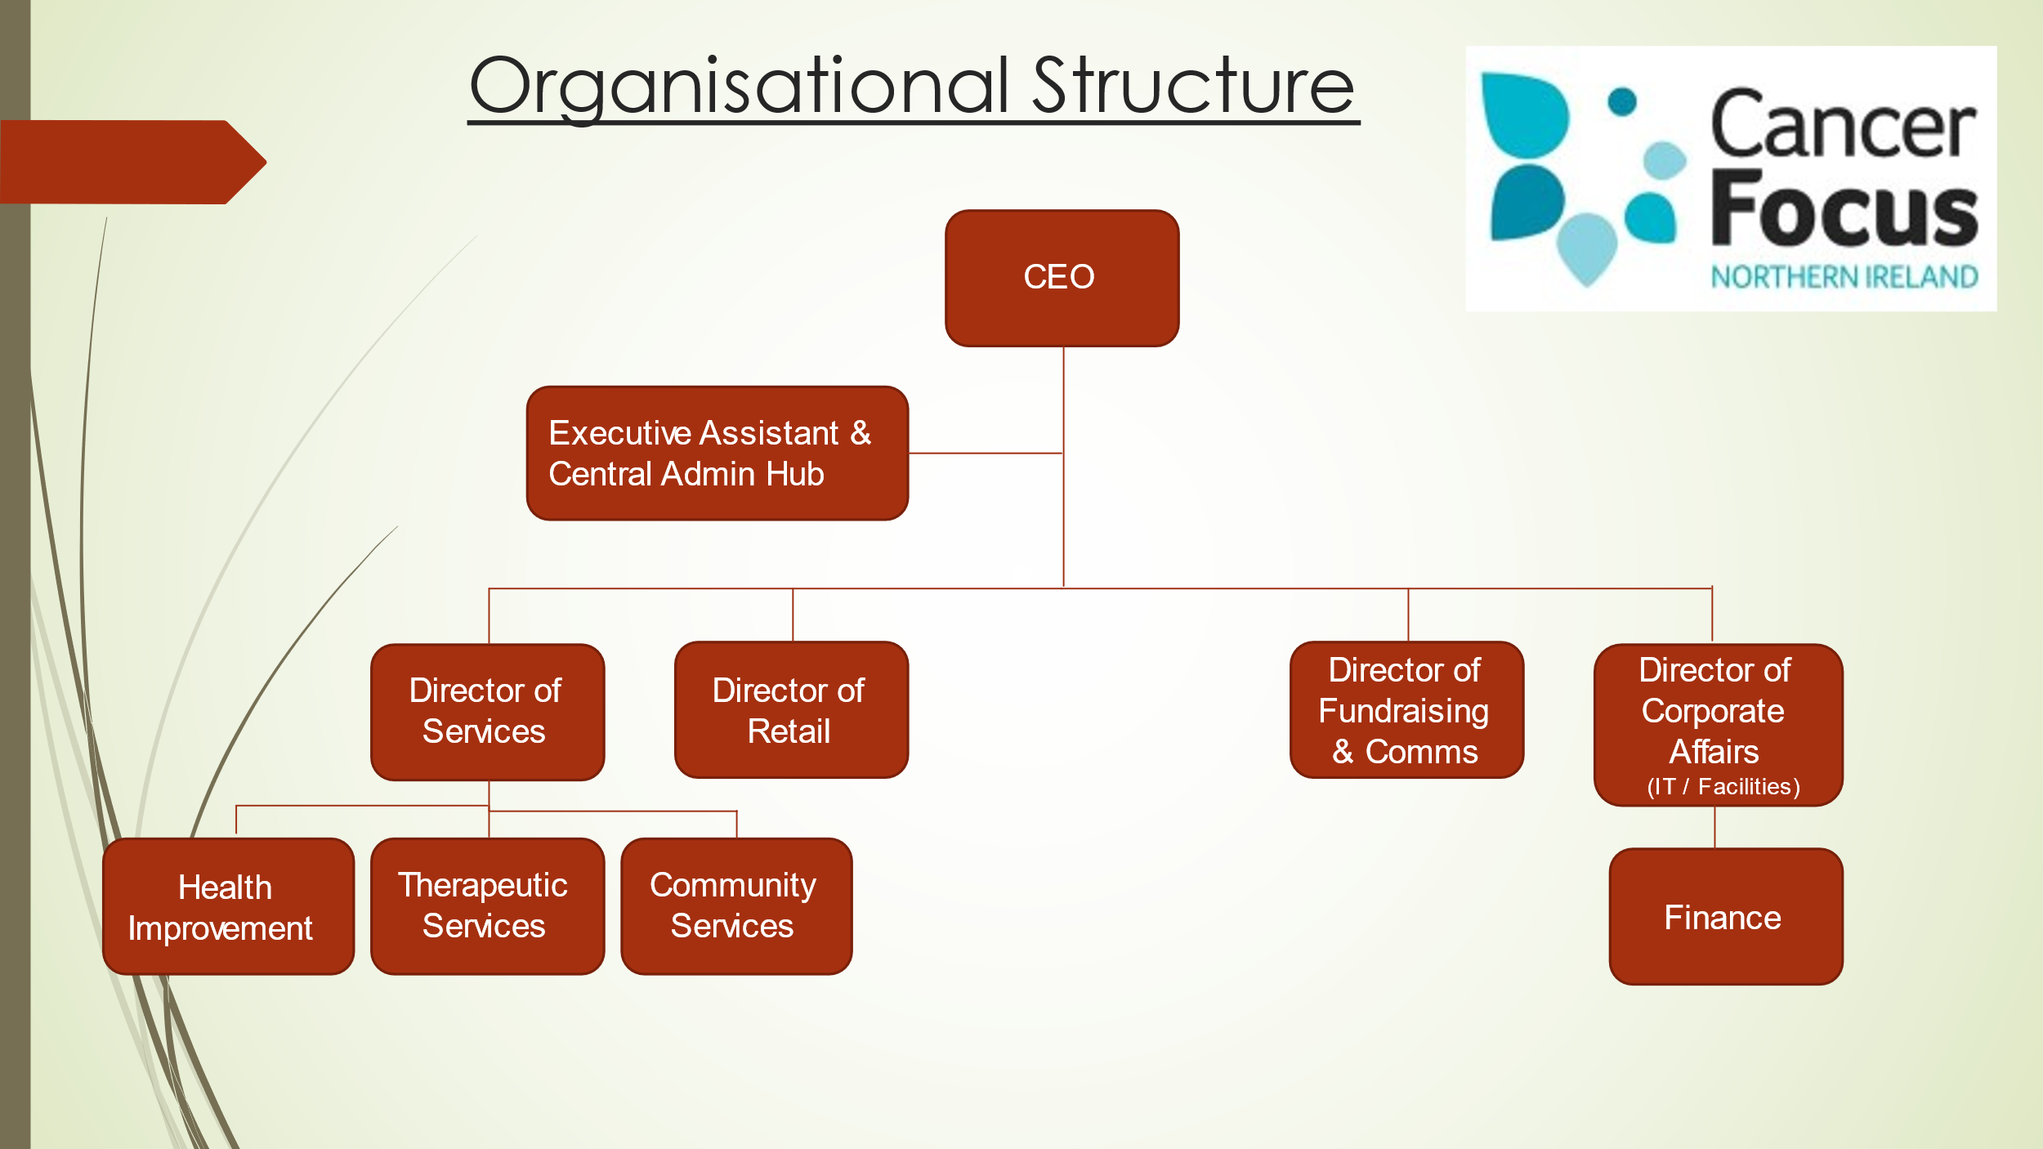

Job Description

Director of Corporate Affairs

Job Description

Job Title: Director of Corporate Affairs

Responsible To: Chief Executive

Responsible For: All Staff within the Corporate Affairs Department

Location: 40/44 Eglantine Avenue, Belfast, BT9 6DX

Salary: PO5 / Points 52-57 / £47,576 - £52,671

Overall Purpose of Post

Provide strategic leadership for the corporate affairs of all Cancer Focus Northern Ireland activities, ensuring the highest levels of professional practice and performance. This portfolio includes the management of finance, IT, personnel, facilities and general management duties.

As a member of the Senior Management Team, to contribute to the overall strategic management and direction of Cancer Focus NI.

Key Responsibilities

Strategic Leadership

- Deliver visionary leadership and strategic direction for all Cancer Focus NI corporate affairs.
- Maintain a high performance and learning culture and strong sense of team ethic.
- To radically transform the way that corporate functions are delivered, ensuring integration, where necessary, in order to drive organisational and cultural change in line with Cancer Focus NI’s transformation agenda.
- Ensure organisational values are lived out in the workplace within the Services Department, including fostering a culture of excellence, accountability and innovation.
- Influence and support the Trustee Board, Chief Executive and Senior Management Team in the strategic direction of the organisation.

Financial Management

- Provide leadership to the Finance Department. This includes delegating, where appropriate, carrying out regular reviews, ensuring the provision of training as necessary, seeking to continuously improve our systems and services in line with legislative requirements and best practice.
- Develop the annual organisational budget to ensure future sustainability in conjunction with the Chief Executive.
- Support colleagues to manage devolved budgets and to ensure that reports are generated for budget managers and departments as required.
- To prepare and present financial reports to the Senior Management Team, Finance & Policy Sub-Committee and the Trustee Board in a timely and accurate manner to enable evidence based decision making.
- To help develop and cost business structures and systems in line with both the finance and organisational strategies.
- To ensure that the organisational Finance Policy and Procedures is updated and implemented effectively.
- To liaise with external auditors in the production of statutory accounts and ensure that all regulatory annual returns are completed as required.

Personnel

- Develop a HR Strategy and operational processes which meets the charity’s needs providing support to the Chief Executive and Senior Management Team on all personnel matters.
- Ensure an appropriate HR Policy and Procedural framework is in place, including compliance with employment legislation.
- Ensure that advice on employment related issues is available to all levels of management when required and act as the main point of contact with external HR advisors.
- Oversee all aspects of pensions and payroll processes, including pay increases, regulatory compliance.
- To ensure compliance with organisational policies and procedures and professional guidelines and standards for all employment related matters, supervision and practice.

IT Management

- Ensure effective strategies and plans are in place for the development and delivery of IT and management information systems and support, to meet the charity’s needs.
- Oversee all IT provision and requirements across the charity, ensuring that key data is protected and accessible.
- Manage the IT Officer and outsourced IT provider to ensure that all Cancer Focus NI staff are appropriately and effectively supported at all times.

Estates & Facilities Management

- Devise and deliver effective estates and facilities development and maintenance strategies.
- Direct the management and maintenance of all estates and facilities to maximise their usage and return on investment, and to protect the charity’s property investment.

Governance / Reporting

- Maintaining a sound, overarching corporate governance and risk management strategy for the organisation to ensure the highest level of accountability in the organisation’s decision-making processes.
- Working with providers of the organisation's professional services (e.g. legal, audit, employment, IT, insurance etc).
- Ensure appropriate and cost-effective insurance cover is in place for the charity and manage all insurance matters.
- To support the Chief Executive and Senior Management Team in long-term business planning and collaborate with the Chief Executive to update the Risk Register to identify potential problem areas and propose solutions.
- To provide support to other departments on the collation of key data and metrics to analyse trends, make recommendations and ensure effective programme / service delivery and impact assessment.
- Ensuring compliance of data collection and retention for services in line with General Data Protection Regulations and Guidance.
- To develop, manage and ensure compliance with all organisational policies and procedures.
Line Management / Team Working

- Responsibility for the day-to-day management, leadership and motivation of direct reports as well as volunteers.
- To ensure the professional development, training, mentoring and performance management of direct reports.
- Contribute to the organisation’s overall strategic and operational planning and participate in any cross departmental project or working groups as required.
- Contributing as a member of the Senior Management Team to wider business improvement, organisational development and overall management of Cancer Focus NI.
- Contributing and reporting to the Trustee Board and attending Trustee Board meetings as required.

Other

- Other duties as may reasonably be allocated by the Chief Executive or Trustee Board from time to time.

This is not a complete statement of all duties and responsibilities of this post. The postholder may be required to carry out any other duties as directed by the Chief Executive which are commensurate with the level of the post. The accountabilities outlined in the Job Description will be supplemented by annual key objectives which will be developed and reviewed with the postholder as part of the annual appraisal process.

Person Specification

Person Specification

Director of Corporate Affairs

This Person Specification sets out the experience, qualifications, skills and qualities which we believe are necessary for this role. Your Application Form should show evidence of how you meet all of the criteria.

 | Essential | Desirable
Experience and Qualifications | - Degree level qualification or suitable relevant professional experience  - Evidence of continuing professional development with a focus on management and leadership | - Postgraduate level qualification
Experience | - A proven track record in senior management, reporting directly to a Board or at Senior Director level  - Significant financial management experience
 | Essential | Desirable
- Experience of managing budgets and resources

- Strong strategic planning, prioritisation and execution skills with the proven ability to manage competing demands and monitor progress and impact through the development of operational plans

- Significant experience of human resource and personnel management

Knowledge | - A comprehensive understanding of company and charity law and the general compliance and regulatory environment in which Cancer Focus NI operates  - A detailed understanding of charity SORP accounting guidelines  - An understanding of the policy context in which Cancer Focus NI operates and the political, economic and social drivers and trends that affect it  - An understanding of personnel and employment law  - An understanding of the impact of cancer on individuals, their families, friends and colleagues  - A demonstrable knowledge of health and social care environment in Northern Ireland
Skills | - Excellent interpersonal skills  - Strong decision-making skills, including a willingness to confront and make tough management decisions when necessary | - Experience of major business process re-engineering and change management initiatives  - Experience of leading IT digital transformation initiatives
 | Essential | Desirable
- Excellent written communication and strategic planning skills

- Proven ability to manage resources to deliver business objectives

- Evidence of the ability to analyse, solve problems and implement change with a successful track record of managing and delivering change

- Excellent financial management and analytical skills

- Excellent IT proficiency and understanding of MS Office 365

Personal Qualities | - Readiness to work flexibly and efficiently whilst maintaining highest professional standards  - A resilient and positive attitude  - The ability to inspire others to achieve in a way which commands respect and provides an environment where others feel motivated  - An open and participative style with excellent leadership / communication skills and commercial acumen

Applicants will hold a full, current driving licence and have access to the use of a car or some other appropriate form of transport to carry out the duties of the post.

Disability

In accordance with the Disability Discrimination Act a person is disabled if they have, or have had, “a physical or mental impairment which has, or has had, a substantial and long-term adverse effect on your ability to carry out normal day to day activities”.

If you consider yourself to have a disability relevant to the position for which you are applying, please contact Julie McConville so that we can process your application fairly, make any specific arrangements for your interview, and make any necessary reasonable adjustments or adaptations, or provide any aids to assist you in completing the duties of the post if appointed.

Equal Opportunities

Cancer Focus NI is an Equal Opportunities Employer and all applications for employment are considered strictly on the basis of merit.

Application Process

The deadline for completed applications is 5.00pm on Friday 29th October 2021.

Please note that we can only accept signed hard-copy applications.

Your completed application should be sent as follows:

Julie McConville
Executive Assistant
Cancer Focus NI
40/44 Eglantine Avenue
Belfast
BT9 6DX

We cannot accept incomplete Applications Forms; Application Forms received after the closing deadline or reformatted Application Forms.

Applicants using Royal Mail should note that 1st class mail does not guarantee next day delivery. It is the responsibility of the applicant to ensure that sufficient postage has been paid, normally a large letter stamp, to return the form.

Contact Details

If you have any queries regarding the recruitment process, please contact Julie McConville by emailing juliemcconville@cancerfocusni.org or phone 028 9068 0744.

Guidance Notes on Completing Your Application Form

- Please complete the Application Form provided to ensure an equitable recruitment process. CVs in lieu of the Application Form cannot be accepted.

- The Application Form is designed to ensure that applicants provide the necessary information to determine how they meet the requirements of the role and the shortlisting criteria.

- You should ensure that ALL sections of the Application Form are completed.

- You should ensure that you provide evidence of your relevant experience in your Application Form, giving length of experience, examples and dates as required.

- It is not sufficient to simply list your duties and responsibilities or to simply state that you meet the criteria as this must be fully demonstrated in response.

- Cancer Focus NI will not make assumptions from the title of the applicant’s post or the nature of the organisation as to the skills and experience gained.

- Write down clearly your personal involvement in any experience you quote. Write “I” statements e.g. I planned meetings, I managed a budget, I prepared a presentation. The panel will be interested in hearing how you actually carried out a piece of work.

- The examples you provide should be concise and relevant to the criteria. This is very important as the examples which you provide may be checked out at interview and you may need to be prepared to talk about these in detail if you are invited to interview. It is your unique role the panel are interested in, not that of your team or division.

- If you do not provide sufficient detail, including the appropriate dates needed to meet the eligibility criteria, the selection panel will reject your application.

- ONLY the details provided by you in your Application Form (the employment history and eligibility criteria) will be provided to the selection panel for the purpose of determining your eligibility for the post.

- The quality of your written English will also be assessed as part of the application process.

For information about this Information Pack, contact Julie McConville at Cancer Focus NI:

E: juliemcconville@cancerfocusni.org

T: 028 9068 0744

W: www.cancerfocusni.org

A: 40/44 Eglantine Avenue, Belfast, BT9 6DX

Charity Registration No. NIC 101307

