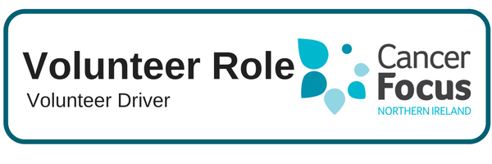

**Purpose of Role**

Many patients find travelling to hospital for multiple appointments very time consuming, expensive and stressful if they have to rely on public transport. **As a volunteer driver you will be providing essential transport for cancer patients to and from their cancer specific appointments**.

**What Does it Involve?**

* Providing cancer patients with door to door transport from their home to the hospital in time for their appointments, and taking them home again afterwards. The days and times will vary according to the needs of the patients.
* Volunteers will be providing the service as part of a team and according to a co-ordinated rota and need to be punctual, reliable, able to co-operate with others and to fulfil their commitments according to our guidelines and training.

**What Can I Expect from the Role?**

* Meet other like-minded people and join our ever growing team of Volunteers.
* Develop skills and gain valuable experience which you can include on your CV.
* Flexibility allows you to fit volunteering into your lifestyle and current commitments.
* Help make a difference to local cancer patients and their families.

**Location**

Transporting patients from their home address to hospital appointments.

**What Skills or Experience do I need?**

* This role is suitable for someone who enjoys meeting people and has good communication and organisational skills.
* It is essential that volunteers are 21 or over and have a full driving licence and access to a comfortable and roadworthy vehicle with the relevant documentation – insurance certificate, MOT certificate.

**Hours**

Flexible – weekdays

One day per month minimum with a commitment of 6 months+

**Training & Support**

There will be comprehensive training provided covering all aspects of the role. In addition any further training required to help you fulfill this role will be provided by Cancer Focus NI. Fuel expenses will be reimbursed at the rate set by HMRC (currently 45p per mile). Any other out of pocket expenses will be reimbursed in line with agreed guidelines.

**Other Details**

This service is currently recruiting in the Mid & East Antrim and Antrim & Newtownabbey Council areas, as well as Belfast and the South Eastern Health Trusts. This role entails an application process including an informal interview, Access NI police check, reference check and training.